**Lab Experiment: 1**

**Aim:** Unit testing using the JUnit tool.

**Question 1:** Write a program in java to find the sum of two numbers and then test it using the Junit tool

**Code:** SumNum.java

package lab1;

public class SumNum {

public int sum(int a,int b)

{

return a+b;

}

}

**JUnit Test Case:** SumNumTest.java

package lab1;

import static org.junit.jupiter.api.Assertions.*;

import org.junit.jupiter.api.Test;

class SumNumTest

{

@Test

void test()

{

SumNum obj = new SumNum();

assertEquals(5,obj.sum(2,3));

}

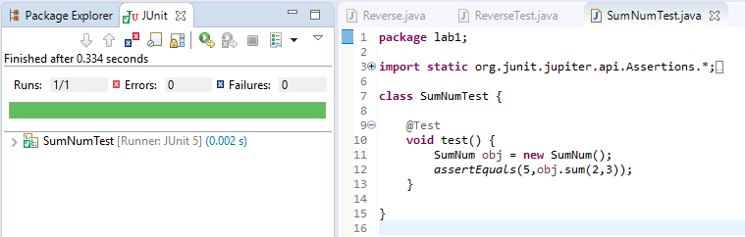}

**Question 2:** Write a program in java to reverse a number and test it using JUnit tool.

**Code:** Reverse.java

package lab1;

public class Reverse {

public int reversenum(int num)

{

int d,r=0;

while(num>0)

{

d=num%10;

r=(r*10)+d;

num=num%10;

}

return r;

}

}

**JUnit Test:**ReverseTest.java

package lab1;

import static org.junit.jupiter.api.Assertions.*;

import org.junit.jupiter.api.Test;

class ReverseTest

{

@Test

void test()

{

Reverse obj = new Reverse();

assertEquals(13,obj.reversenum(31));

}

}

